Firstly I collected provincial data concerning people's livelihood, medical care and environment; they are waste gas (mainly SO2), waste water, Greenland and death rate. Then I highlighted data in the map of China via visualization technology. Took circles of different sizes and colors to indicate the size and categories of data; exhibited the data changes within a decade through timeline. The main UI is as following:

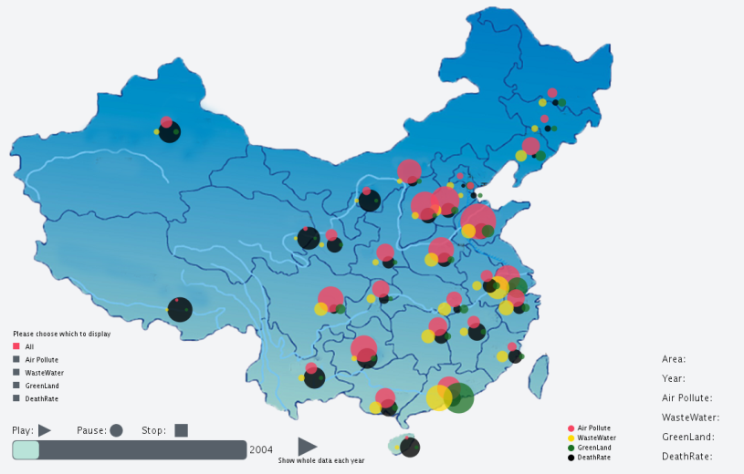

Also with some interactions, presented the histogram and line chart of data changes via mouse interaction, as following:

